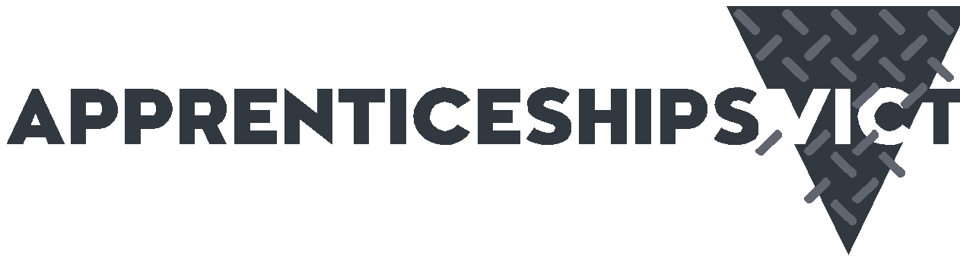

**Supervising apprentices and trainees:**

**employer fact sheet**

**Supervision in the workplace is essential for apprentices or trainees to become competent in their chosen trade or vocation, and to work safely, confidently, and effectively.**

Employers who take on and train apprentices or trainees play an important role in developing both their own workforce and the workforce of their industry.

**What is supervision?**

Supervision is the oversight and coordination of on-the-job training provided to an apprentice or trainee engaged under a Training Contract.

Apprentices and trainees need varying levels and types of supervision as they acquire skills and gain confidence in the workplace.

|  |
| --- |
| **THERE ARE THREE TYPES OF WORKPLACE SUPERVISION:** |
| **Direct supervision** – Direct supervision is the default type of supervision and must be maintained during the training of a particular skill until the apprentice or trainee has demonstrated competence in that skill and can perform that skill safely. Further information  on when to use different types of supervision is provided in the Supervision Guidance Note. |
| **Indirect supervision** – Intermittent and oversight of the apprentice or tr a frequency assessed as safe and  for them at the time. Supervisor stays apprentice or trainee. |
| **Broad supervision** – The supervisor is always near the learner. Provides for checking of completed tasks and s overall performance. |

Some apprentices or trainees will be in greater need of direct supervision and others less

so. The time required to progress from direct supervision to indirect and broad supervision will vary from worker to worker.

It is the employer and supervisor’s responsibility to make a reasonable assessment of what is appropriate for the apprentice or trainee in their workplace.

Keeping training records up to date is one of the obligations as an employer and will help explain the training and skills approach taken, and why, to the Victorian Registration and Qualifications Authority.

Keeping evidence of the on-the-job training, they provide also means employers can demonstrate adherence to their responsibilities under the Training Contract and support their apprentices and trainees to progress.

Regardless of who is tasked within the organisation to carry out the role of supervisor, the employer always remains responsible for the quality of the on-the-job training, and the safety and supervision of their apprentice or trainee in accordance with the *Occupational Health and Safety Act 2004* (OHS Act).

monitoring ainee at appropriate

near the

not quality

upervision of

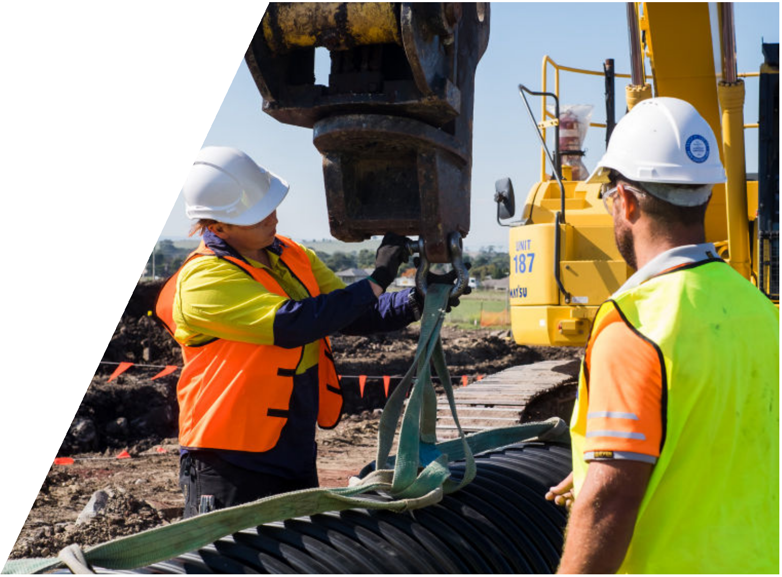

**Supervisor requirements**

Employers are responsible for ensuring the people they nominate as supervisors are suitable and appropriate to oversee and coordinate the training of an apprentice or trainee on the job.

|  |  |
| --- | --- |
| **QUESTIONS EMPLOYERS SHOULD CONSIDER WHEN PUTTING IN PLACE SUPERVISORY ARRANGEMENTS INCLUDE:** | |
|  | • Does the potential supervisor have an aptitude for and interest in training others? |
|  | • Does the potential supervisor have appropriate qualifications, knowledge and skills? Are they competent and experienced in the tasks they will be overseeing? |
|  | • Does the potential supervisor have a good understanding of the trade or vocation? |
|  | • Is the potential supervisor a ‘fit and proper’ person to guide and oversee trainees and apprentices? Do they pose any risks to the trainee/apprentice? Do they have any serious criminal history? Employers should remember that apprentices and trainees are often young and lack life experience. |
|  | • Is the potential supervisor capable of using the correct type of supervision for each apprentice or trainee in consideration of their age, life experience, competence and workplace risks? |
|  | • Is the potential supervisor capable of confirming on-the-job competency and updating training records for the apprentices and trainees they are responsible for? |
|  | • Does the potential supervisor understand their obligations under the OHS Act? |
|  | • What is the appropriate number of apprentices or trainees the potential supervisor can supervise at a given time to ensure workplace safety and comply with the Training Contract, relevant industrial agreements, the level of supervision required and all applicable laws? |
|  | • Where the apprentice or trainee is a child or young person (under the age of 18), is the supervisor (and other people working with the apprentice or trainee) suitable and supported to reflect child safety and wellbeing values in practice? |

Note: supervisors and employers of **apprentice electricians**, must refer to the Energy Safe Victoria Supervision Guidelines [Requirements for the effective supervision of apprentice electricians](https://www.energysafe.vic.gov.au/licensing/your-responsibilities/employers-electricians/requirements-effective-supervision#new-requirements-%E2%80%93-effective-1-september-2025)

**Legal obligations**

Victorian law requires employers to supervise apprentices and trainees in the workplace.

The Victorian Registration and Qualifications Authority (VRQA) is responsible for regulating apprenticeships and traineeships in Victoria, including monitoring and enforcing compliance.

When an employer takes on an apprentice or trainee, they enter into a formal agreement known as a ***Training Contract***, binding both parties to obligations under the arrangement.

The employer must enrol the apprentice or trainee in a vocational education and training (VET) course with a Registered Training Organisation (RTO) ***within three months*** of starting the job.

The employer must also arrange for the signing and lodgement of a ***Training Plan*** that describes what training is to be provided, how, when, where and by whom.

This includes on-the-job training and assessment of competency in the necessary skills for the trade or vocation.

**Supervision responsibilities for employers**

Employers are required to provide supervision that enables the apprentice to safely attain the standards of skill and knowledge required for their qualification. Safety supervision plays a key role in reducing injuries and fatalities in the workplace.

The employer must nominate for the trainee or apprentice a supervisor from within their organisation. The supervisor must have appropriate qualifications, knowledge and skill and

be a fit and proper person to supervise the training. However, the employer remains responsible for the quality of the on-the-job training.

The employer must also work with the Registered Training Organisation and the apprentice or trainee to follow the Training Plan, ensuring skills are developed and progression occurs. Training records must be kept up to date.

**Supervisor requirements**

Employers are responsible for ensuring the people they nominate as supervisors are suitable and appropriate to oversee and coordinate the training of an apprentice or trainee on the job.

There is no requirement for a trainee or apprentice to have a single supervisor.

It is common for apprentices and trainees to work with several supervisors on different worksites or tasks.

In fact, exposure to several supervisors may enhance the training experience for the apprentice or trainee as each supervisor will bring their individual strengths and skills to the role, and the learner will be exposed to different approaches, team members and environments.



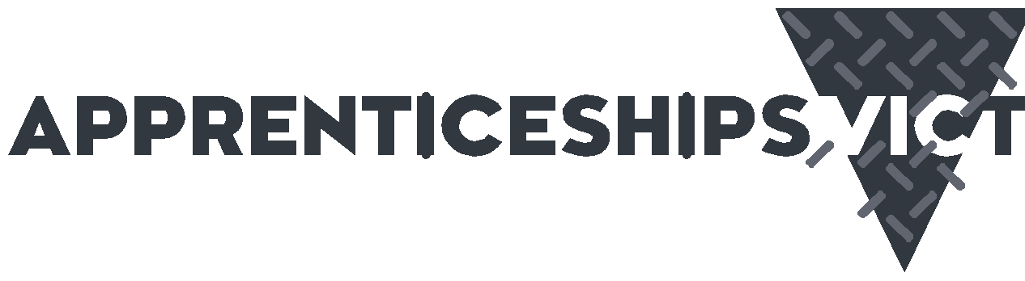

**Who can help?**

**Apprenticeships Victoria (AV)**

AV’s Apprentice Helpdesk and Apprenticeship Support Officers (ASOs) provide free information, support, advice and referrals. They can assist you to resolve workplace, training and personal issues that may impact on an apprenticeship or traineeship.

*Apprenticeship Help Desk*

1300 311 820 [apprenticehelpdesk@djsir.vic.gov.au](mailto:apprenticehelpdesk@djsir.vic.gov.au)  
[www.apprenticeships.vic.gov.au](http://www.apprenticeships.vic.gov.au)

**Victorian Registration and Qualifications**

**Authority (VRQA)**

The VRQA is an independent statutory authority that works to assure the quality of education and training in Victoria. The Authority regulates apprenticeships and traineeships and makes routine workplace visits to ensure both parties are meeting their obligations. The VRQA can provide advice, help to resolve disputes and investigate when required.

*Apprenticeship and traineeship enquiries*

1300 722 603 [vrqa.apprenticeships@education.vic.gov.au](Mailto:vrqa.apprenticeships@education.vic.gov.au) [www.vrqa.vic.gov.au](http://www.vrqa.vic.gov.au)

**WorkSafe Victoria**

WorkSafe is Victoria’s workplace health and safety regulator, and workplace injury insurer.

*Advisory Services*

1300 136 089  
[worksafe.vic.gov.au](http://worksafe.vic.gov.au)

Online enquiry form:

[www.myworksafe.vic.gov.au/s/customer-enquiry](http://www.myworksafe.vic.gov.au/s/customer-enquiry)

**Apprentice Connect Australia Providers (ACAP)**

ACAP’s are contracted by the Australian Government Department of Employment and Workplace Relations to provide a free

advice and support service to employers and apprentices/trainees. The ANP is required

to visit employers and apprentices/trainees to assist in the completion of the Training Contract.

1800 020 108

[www.australianapprenticeships.gov.au/](http://www.australianapprenticeships.gov.au/search-aasn)

[search-aasn](http://www.australianapprenticeships.gov.au/search-aasn)

**Fair Work Ombudsman**

The Fair Work Ombudsman investigates allegations of wage theft. They also provide information on pay and entitlements for apprentices and trainees via their website or hotline.

13 13 94

[www.fairwork.gov.au](http://www.fairwork.gov.au)

**Energy Safe Victoria**

Energy Safe Victoria is the state energy safety regulator for gas, electricity and pipelines. Employers of apprentice electricians must follow the energy safe guidelines (linked).

[Requirements for the effective supervision of apprentice electricians | Energy Safe Victoria](https://www.energysafe.vic.gov.au/licensing/your-responsibilities/employers-electricians/requirements-effective-supervision#new-requirements-%E2%80%93-effective-1-september-2025)

[Contact us | Energy Safe Victoria](https://www.energysafe.vic.gov.au/about-us/contact-us)

*This fact sheet contains information from Apprenticeships Victoria’s Supervision Guidance Note, which can be found on the Apprenticeships Victoria website:* [*www.apprenticeships.vic.gov.au.*](http://www.apprenticeships.vic.gov.au)