**Supervision fact sheet for apprentices and trainees**

**Effective workplace supervision helps you to work safely, confidently, and effectively – and is critical to your success.**

Supervisors act as role models and coaches and play an important part in keeping you safe and supporting you to develop your skills.

**What is supervision?**

Apprentices and trainees receive varying levels and types of supervision as they learn skills and gain confidence in the workplace.

|  |  |
| --- | --- |
| **THERE ARE 7 STEPS TO EFFECTIVE SUPERVISION:** | |
|  | **1. Explain the big picture** |
|  | **2. Take it step-by-step** |
|  | **3. Demonstrate** |
|  | **4. Practice makes perfect** |
|  | **5. Provide feedback** |
|  | **6. Advise** |
|  | **7. Engage with the learner** |

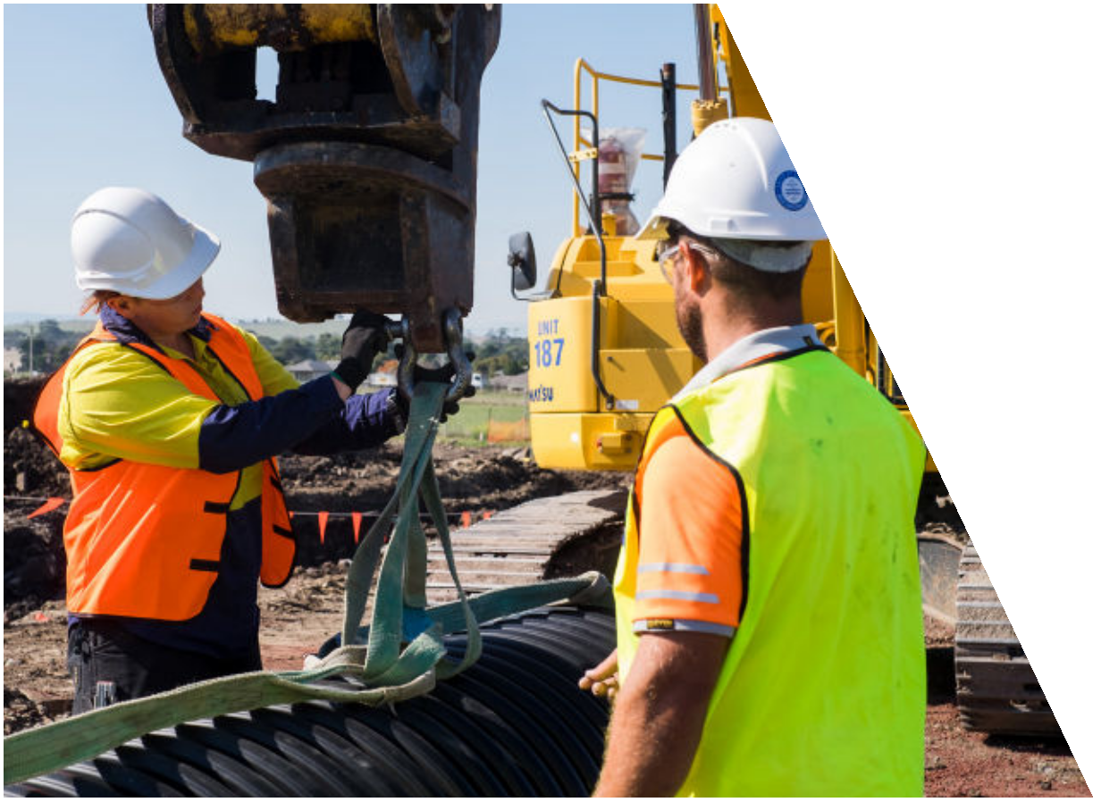

|  |
| --- |
| **THERE ARE THREE TYPES OF WORKPLACE SUPERVISION:** |
| **Direct supervision** – Your supervisor is with you all the time. This is the level of supervision you should expect while you are learning a new skill, until such time as you can perform that skill safely. |
| **Indirect supervision** – Your supervisor is nearby and is checking in on you and your work, making sure you are safe. |
| **Broad supervision** – Your supervisor is not always nearby. You will be doing work that you already know how to do safely. Your supervisor will be checking the quality of your work and your overall performance. |

It is the employer and supervisor’s responsibility to assess what is appropriate for you in their workplace.

There is no requirement for a trainee or apprentice to have a single supervisor and it is common for apprentices and trainees to work with several supervisors on different worksites or tasks.

In fact, exposure to several supervisors may enhance your training experience, as each supervisor will

bring their individual strengths and skills to the role, and you will be exposed to different approaches, team members and environments.

Note: **apprentice electricians**, should refer to the Energy Safe Victoria Supervision Guidelines [Requirements for the effective supervision of apprentice electricians](https://www.energysafe.vic.gov.au/licensing/your-responsibilities/employers-electricians/requirements-effective-supervision#new-requirements-%E2%80%93-effective-1-september-2025)

**Who can help**

**Victorian Registration and Qualifications**

**Authority (VRQA)**

The VRQA is an independent statutory authority that works to assure the quality of education and training in Victoria. The Authority regulates apprenticeships and traineeships and makes routine workplace visits to ensure both parties are meeting their obligations. The VRQA can provide advice, help to resolve disputes and investigate when required.

*Apprenticeship and traineeship enquiries*

1300 722 603

[www.vrqa.vic.gov.au](https://www2.vrqa.vic.gov.au/)

**Apprenticeships Victoria (AV)**

AV’s Apprentice Helpdesk and Apprenticeship Support Officers (ASOs) provide free information, support, advice and referrals. They can assist you to resolve workplace, training and personal issues that may impact on an apprenticeship or traineeship.

*Apprenticeships Help Desk*

1300 311 820

[apprenticehelpdesk@djsir.vic.gov.au](mailto:apprenticehelpdesk@djsir.vic.gov.au)

[www.apprenticeships.vic.gov.au](http://www.apprenticeships.vic.gov.au/)

**WorkSafe Victoria**

WorkSafe is Victoria’s workplace health and safety regulator, and workplace injury insurer. They provide a wide range of information and guidance on their website or over the phone

*Advisory Services*

1300 136 089

[www.worksafe.vic.gov.au](http://www.worksafe.vic.gov.au)

Online enquiry form: [www.myworksafe.vic.gov.au/s/customer-enquiry](http://www.myworksafe.vic.gov.au/s/customer-enquiry)

**Supervision of apprentices and trainees** Employers must provide supervision that enables you to safely learn the standards of skill and

knowledge needed for their qualification – and

job. Safety supervision plays a key role in reducing

injuries and fatalities in the workplace.

The employer must nominate a supervisor for you. The supervisor must have appropriate qualifications, knowledge and skill and be a fit and proper person to supervise your training. But the employer remains responsible for the quality of

on-the-job training.

The employer must also work with you and the Registered Training Organisation providing your training to follow the Training Plan, ensuring your skills are developed and progression occurs. Training records must be kept up to date.

If you do not believe you are being appropriately supervised you should let the apprenticeship and traineeship regulator, the Victorian Registration and Qualifications Authority, know.

Alternatively, you can speak with one of Apprenticeships Victoria’s Apprenticeship Support Officers. If you believe you are unsafe you should speak directly to the workplace health and safety regulator, WorkSafe. 

*This fact sheet contains information from Apprenticeships Victoria’s Supervision Guidance Notes, which can be found on the Apprenticeships Victoria website:* [*www.apprenticeships.vic.gov.au*](http://www.apprenticeships.vic.gov.au)

*This fact sheet contains information from Apprenticeships Victoria’s Supervision Guidance Notes, which can be found on the Apprenticeships Victoria website:* [*www.apprenticeships.vic.gov.au*](http://www.apprenticeships.vic.gov.au)

**Fair Work Ombudsman**

The Fair Work Ombudsman investigate allegations of wage theft. They also provide information on pay and entitlements for apprentices and trainees via their website.

[www.fairwork.gov.au](http://www.fairwork.gov.au)

**Fair Work Ombudsman**

The Fair Work Ombudsman investigates allegations of wage theft. They also provide information on pay and entitlements for apprentices and trainees via their website.

13 13 94

[www.fairwork.gov.au](http://www.fairwork.gov.au)